Project Euler Problem 894

Consider a unit circle C₀ on the plane that does not enclose the origin. For k >= 1, a circle C_{k} is created by scaling and rotating C_{k-1} with respect to the origin. That is, both the radius and the distance to the origin are scaled by the same factor, and the centre of rotation is the origin. The scaling factor is positive and strictly less than one. Both it and the rotation angle remain constant for each k.
It is given that C₀ is externally tangent to C₁, C₇ and C₈, as shown in the diagram below, and no two circles overlap.
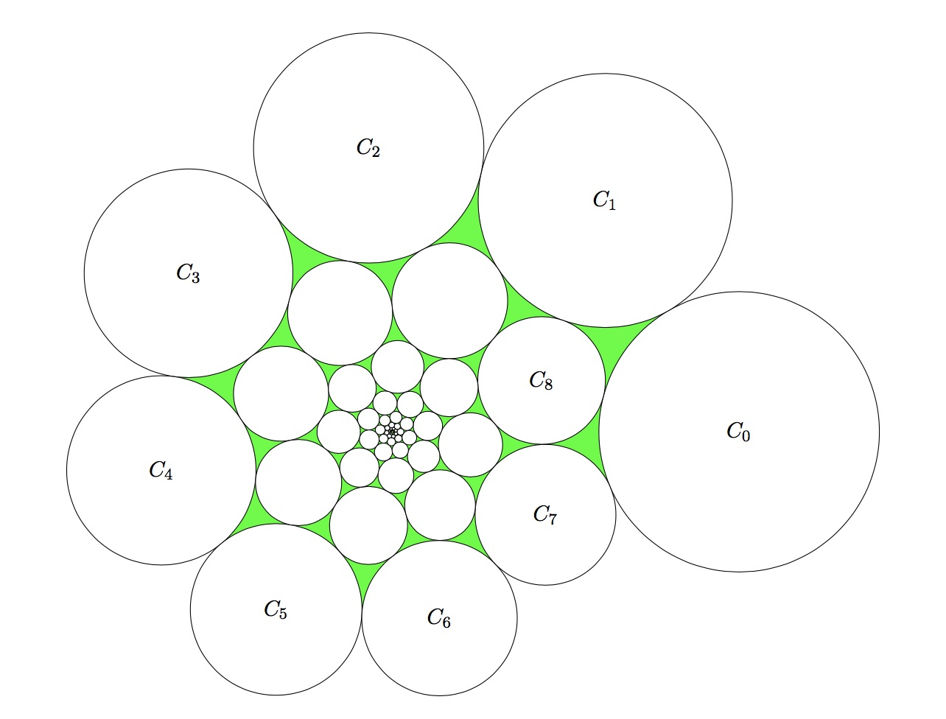
Find the total area of all the circular triangles in the diagram, i.e. the area painted green above.
Give your answer rounded to 10 places after the decimal point.

Coordinate System
Let us label the origin O. The center of each circle C_{n} is called c_{n}. Without loss of generality, we can place c₀ on the positive x-axis. The sequence of circles spirals into the origin, since the radius is a geometric sequence that tends to 0 in the limit.

Trigonometric Identities
We will use a number of trig identities and laws in this proof:
Law of Cosines:

Law of Sines:

Angle Sums and Differences:

Control Parameters
There are 3 parameters that control the spiral:
- r – the distance from c₀ to origin
- s – the scale factor between C_{n} and C_{n+1}
- θ – the rotation angle from C_{n} to C_{n+1}

Significant Triangles
There are three triangles that we can use to create 3 equations to solve for the 3 unknowns:
- OC₀C₁
- OC₇C₀
- OC₀C₈
Let us look at the coordinates of the circles used in these triangles:
- C₀ – the reference circle. Its radius is 1 and its center is at [ r, 0 ]
- C₁ – the first rotated circle. Its radius is s and its center is located rs units from the origin
- C₇ – the seventh rotated circle. Its radius is s⁷ and its center is located rs⁷ units from the origin
- C₈ – the eighth rotated circle. Its radius is s⁸ and its center is located rs⁸ units from the origin
We can use the Law of Cosines on each of these triangles to construct an equation in the 3 variables. Let us examine each in turn.

Triangle OC₀C₁
This triangle connects the centers of the first two circles, C₀ and C₁, to the origin O. The angle at the origin has the value θ by definition. The edge opposite the origin is C₀C₁, which has length 1 + s. The edge OC₀ has length r, and the edge OC₁ has length rs. When we apply the Law of Cosines to this triangle, we get this equation:

Triangle OC₇C₀
This triangle connects the centers of C₀ and the first tangent circle on the inner spiral C₇ with the origin O. We know the counterclockwise angle from the positive x-axis to c₇ is 7θ, so the angle at the origin is 360 – 7θ. The edge opposite the origin is C₀C₇, which has length 1 + s⁷. The edge OC₀ still has length r, and the edge OC₇ has length rs⁷. When we apply the Law of Cosines to this triangle, we get this equation:

We can apply the angle difference identity to simplify the cosine term:

We can clean up the equation above with this identity:

Triangle OC₀C₈
This triangle connects the centers of C₀ and the second tangent circle on the inner spiral C₈ with origin O. We know the counterclockwise angle from the positive x-axis to c₈ is 8θ, so the angle at the origin is 8θ – 360. The edge opposite the origin is C₀C₈, which has length 1 + s⁸. The edge OC₀ still has length r, and the edge OC₈ has length rs⁸. When we apply the Law of Cosines to this triangle, we get this equation:

We know the cosine function has a period of 360 degrees, so there is this identity:

We can clean up the equation above with this identity:

The System of Equations
We now have this trio of equations of the 3 unknowns:

Parameter Ranges
Each of the 3 parameters has a limited range due to the tangent relationships. We know that C₀ is tangent to both C₇ and C₈, so we can easily establish extrema for θ. These plots show the visualization of the min and max values for θ, which correspond to the other extremum for s.
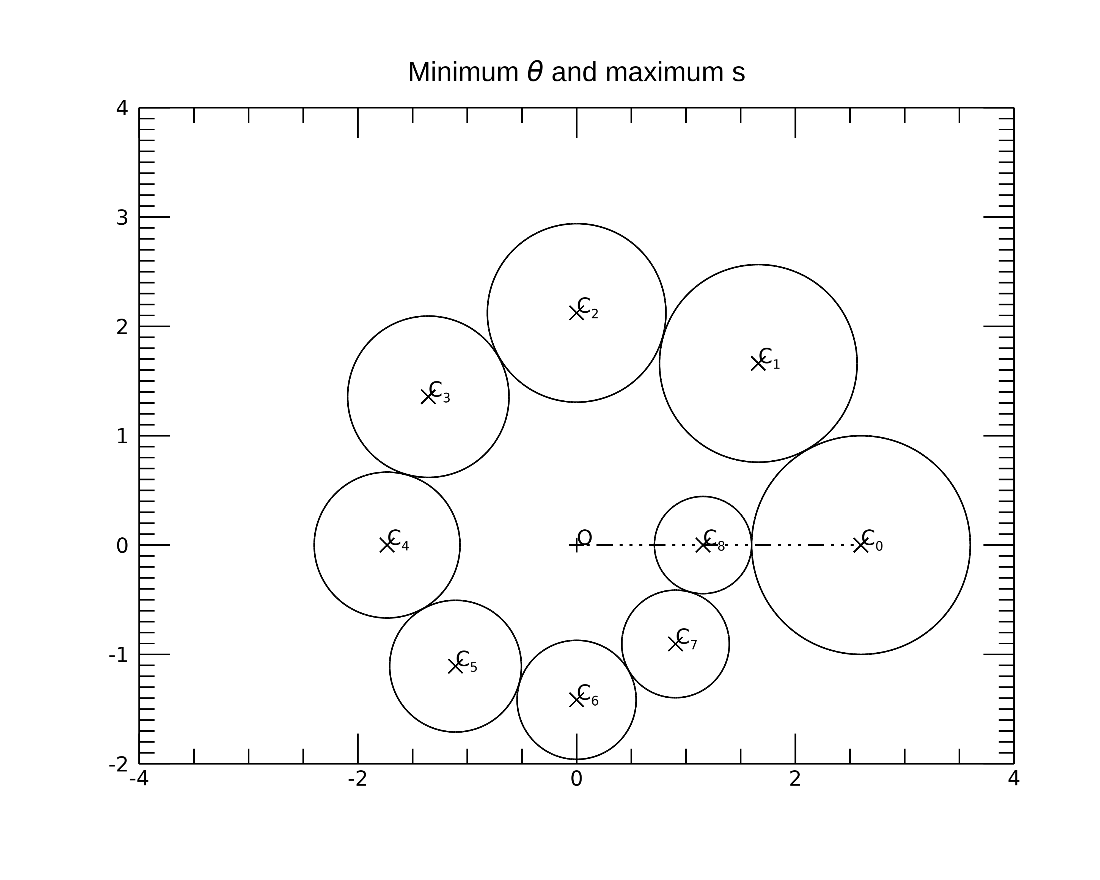
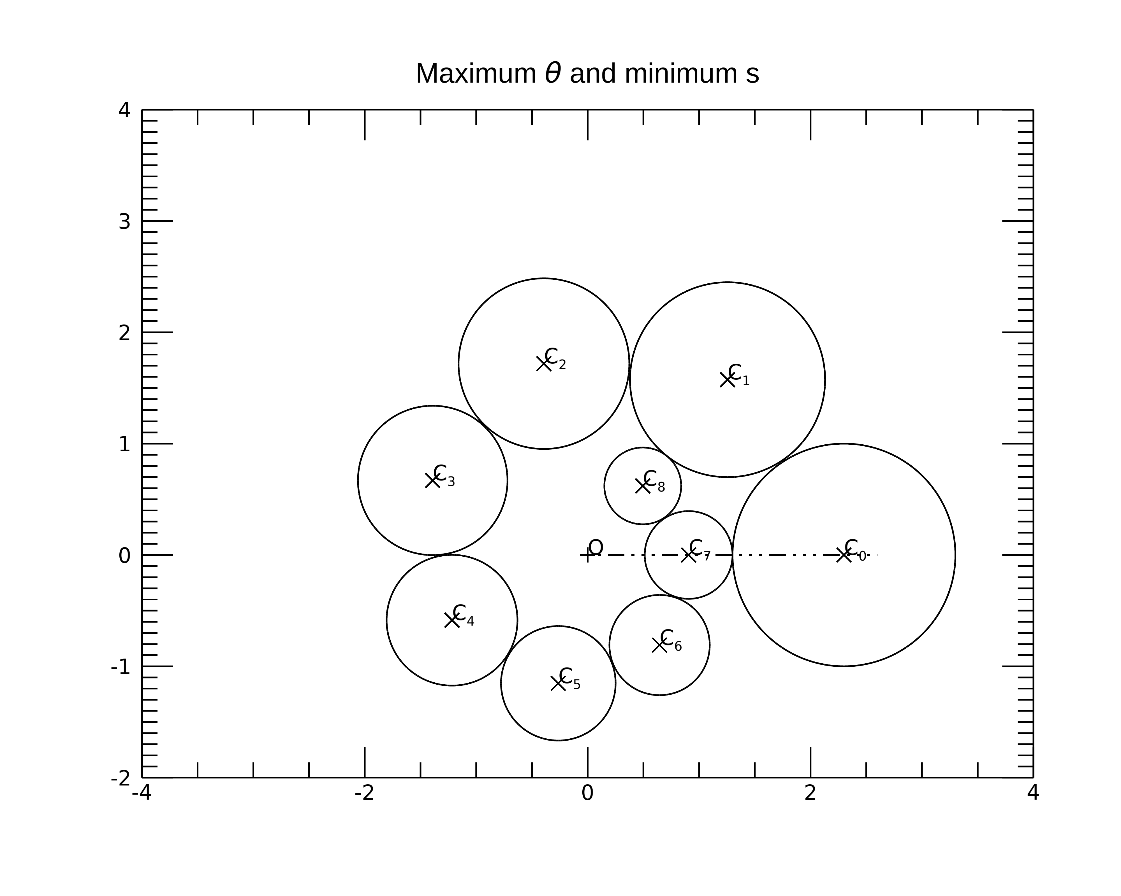

When θ is at its minimum, we see that O, c₈, and c₀ are collinear. So we know that OC₀ is equal to OC₈ plus the two radii:

Conversely,

We can insert this into the equation derived from triangle OC₀C₁ to solve for the s. We could try to solve for r, but the roots make that much more annoying.

Factor out 2s and rearrange by power:

We can’t solve this exactly, but we can use the Newton-Raphson Method to get a numerical solution:

in this case,

so

We have to be a little careful with the starting guess s₀. Every time involves a power of s, so s₀ = 0 would result in the denominator being really close to 0 (thanks to truncation error), which means that s₁ would trend towards infinity.
The numerical solution converges very quickly, in 5 iterations.

We return to when θ is at its maximum, we see that O, c₇, and c₀ are collinear. So we know that OC₀ is equal to OC₇ plus the two radii:

Conversely,

We can insert this into the equation derived from triangle OC₀C₁ to solve for the s:

Factor out 2s and rearrange by power:

Again apply Newton-Raphson, but this time:

Again, we can’t start with s₀ = 0, but the numerical solution converges very quickly, in 6 iterations.
We end up with these ranges that constrain the parameter values:
param | min | max
r | 2.2827657055313577 | 2.5937106911251053
s | 0.87438171014654109 | 0.90335467574537198
θ | 45 | 360/7 = 51.428571428571431

Solving the System of Equations
We will use gradient descent to solve the equations. We define the vector x as:

We use this to define a vector function:

This is used to define the objective function:

This function will have a non-negative value for all values in the domain, and should have a single zero at the desired solution.
For the gradient descent algorithm we need the Jacobian matrix for the vector function:

The partial derivatives are:

So the Jacobian is:

We create functions to calculate the vector G(x) and J_{G}(x), and then select a starting guess and iterate. For the starting guess, we chose the mean value of the parameter’s range:

The iteration takes the form:

Experimentation with the scale factor came up with:

We also try both and to see which yields a value of that is smaller, and choose that direction. The numerical solution we converged to after 5,000,000,000 iterations was:

This yields a value of F(x) of 2.76E-22.

The Green Area
If we stare long enough at the original diagram, one may notice that the green circular triangles fall into one of two families, which we are calling the innies and the outies. There is one of each of these attached to each circle in the spiral. The inny triangles are identified by the label A_{n} on the normal triangle that encapsulates them in red, and the outy triangles are identified by the label B_{n} on the normal triangle that encapsulates them in cyan, in the following diagrams.
The A_{n} triangles are encapsulated by a normal triangle connecting the center of 3 of the circles. For a given n, the triangle A_{n} connects the centers of the circles C_{n}C_{n+7}C_{n+8}. Each one of these triangles is a rotated and scaled version of the previous, following the same spiral as the circles. Therefore the area of triangle A₁ is s² times of A₀, and the area of A₂ is s² times the area of A₁, etc… The circle radii are scaled by s, but we have to square this for the area ratios. These triangle areas form the geometric sequence:
A₀, s²A₀, s⁴A₀, s⁶A₀, s⁸A₀, …
So to total area of all the A_{n} triangles is the infinite geometric sum:
A₀ + s²A₀ + s⁴A₀ + s⁶A₀ + s⁸A₀ + ...
We can factor out the A₀ to get this expression:
A₀ (1 + s² + s⁴ + s⁶ + s⁸ + …)
We know that s < 1, so the infinite series converges to A₀ / (1 – s²).
The same logic can be applied to the B_{n} triangles, thing in this case B_{n} connects the centers of circles C_{n}C_{n+1}C_{n+8}.
So solving the problem comes down to calculating the area of A₀ and B₀ and then applying the geometric sum and adding. To calculate the area of the circular triangle, we can calculate the area of the normal triangle that encapsulates it and the subtract the portions of the 3 circles that overlap said triangle.
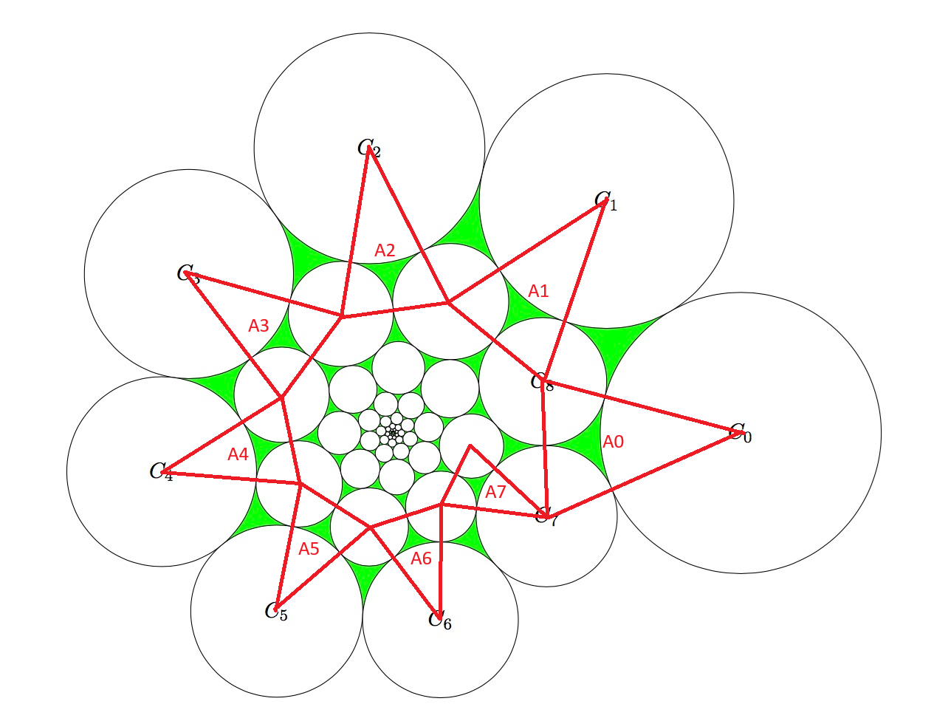

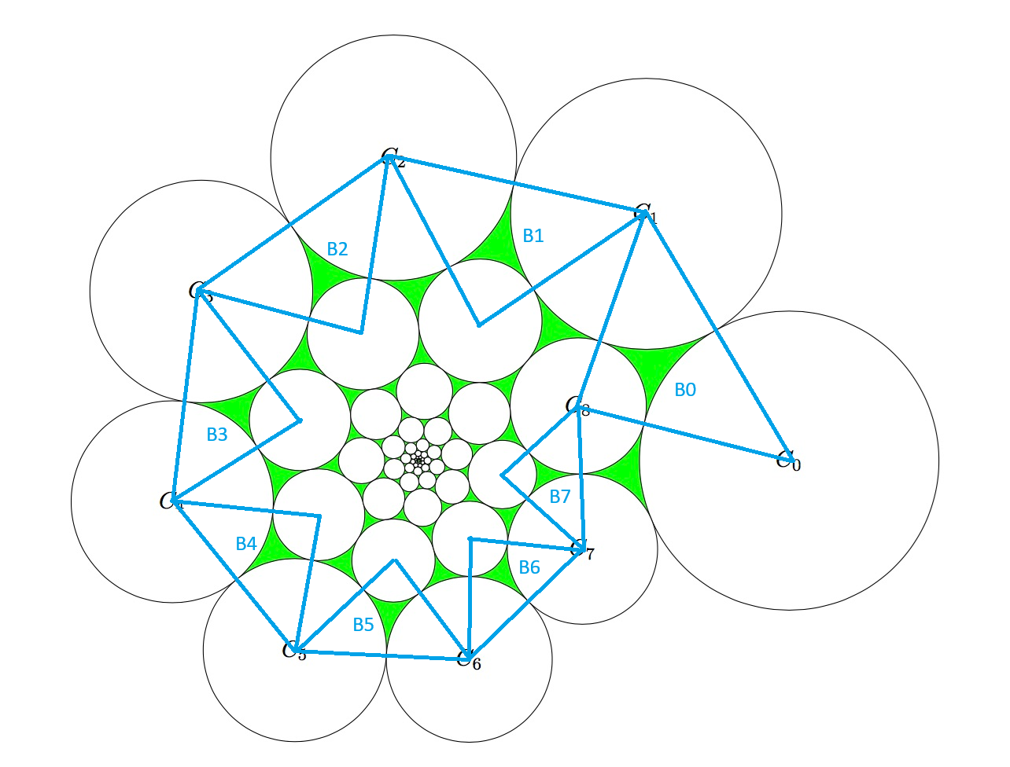

Inny
Let’s start with A₀. The triangle connects C₀, C₇, and C₈. We know their radii are 1, s⁷, and s⁸, respectively. So the triangle has edges 1 + s⁷, 1 + s⁸, and s⁷+ s⁸. We can use Heron’s semiperimeter formula for the area of triangle knowing only its edges:

When the edges are a, b, and c, and s is the semiperimeter: s = (a + b + c) / 2. The overlapping use of s here is a little inconvenient, so we will call the semiperimeter p for clarity.

Plugging the values into Heron’s formula yields:

We can use the Law of Cosines to calculate each of the angles in A₀. Once we have the angles, then the area of the circular wedge is just half that angle (in radians) times the radius squared. We will use the variable θ_{n} to be the angle inside the triangle C_{n}.

We can confirm that these three angles sum to 180º. Now we can use these angles to calculate the area of the inny circular triangle:

Outy
Now we can analyze B₀. The triangle connects C₀, C₁, and C₈. We know their radii are 1, s, and s⁸, respectively. So the triangle has edges 1 + s, 1 + s⁸, and s+ s⁸. This time the semiperimeter is:

Using Heron’s semiperimeter formula yields:

Next we apply the Law of Cosines to the B₀ triangle, though this tile we will use ɸ_{n} for the angles instead of θ_{n}.

Again we can confirm that the three angles sum to 180º. Now we can use these angles to calculate the area of the outy triangle:

Now that we have the two circular triangles adjacent to C₀, we can calculate the final answer:

An Alternate Area Calculation
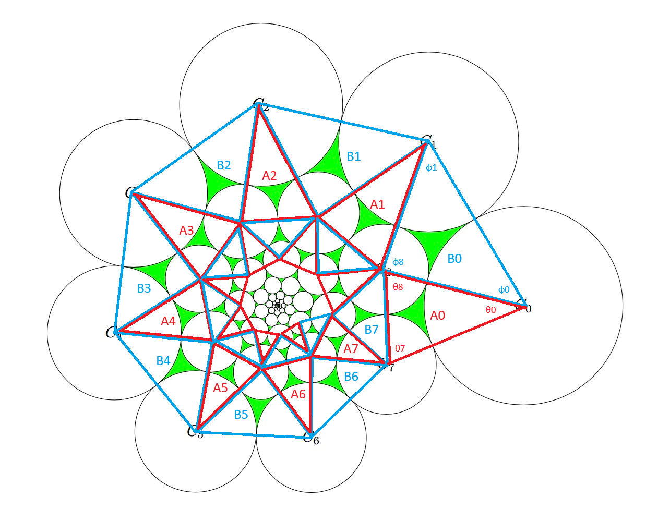
There is another way to calculate the area of all the green circular triangles. Consider this image, that shows both the A_{n} and B_{n} triangles overlaid on the circles:

We can see how the triangles form a nautilus pattern, and together will cover the entire polygon of their convex hull. This is almost equal to the sum of the areas of all the circles and the area of the green circular triangles. The difference in these 2 areas is the portions of C₀ through C₇ that lie outside the convex hull. We can calculate this difference and use it to calculate the green area:

The challenge is calculating those extra areas. These fall into 3 categories:
- C₀ : part of circle outside A₀ and B₀
- C₁ – C₆ : part of circle outside A_{n}, B_{n-1}, and B_{n}
- C₇ : part of circle outside A₀, A₇, B₆, and B₇
This translates into these areas:

Adding these together yields the total extra area:

We know the partial sums of the geometric series are:

In this case, a = 1 or s² and r = s², so we get:

We can now revisit the equation for the green area:

We know that C₀ is a unit circle, so its area is π. So this becomes:

A Second Alternative
We use the same diagram above, but this time instead of subtracting pie wedges we add them.
If we look at the spiral of triangles, we note that every circle from C₈ on is fully covered by them. So instead of looking at the extra parts of C₀ – C₇ that are outside the triangles, we look at the wedges of C₀ – C₇ that overlap the triangles:

The wedges areas are very related to the extra areas above, with corresponding angles:

Adding these together yields the total wedge area:

We can now rearrange and plug in this sum into the original equation:

We also need to evaluate the sum of the circle areas, since it doesn’t start with C₀ anymore, but C₈ now. The area of C₈ is easy to calculate as:

The final equation then becomes:

